Arabic Language Basics

Section: L01

Assignment Date: 8/09/2021

Name: Talha Abdullah Punjabi

QUID: 201903446

Unit 8- Writing Letters

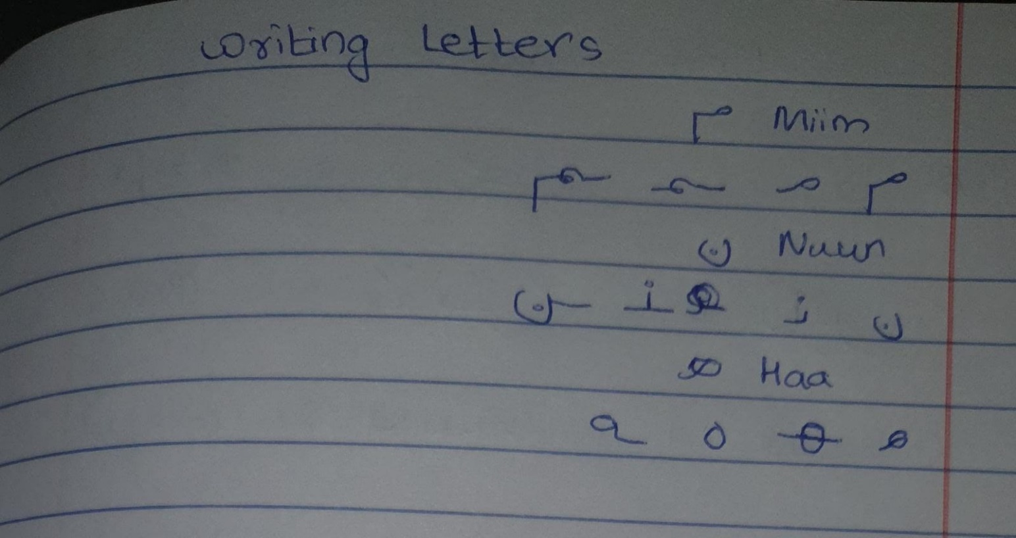

New vocabulary

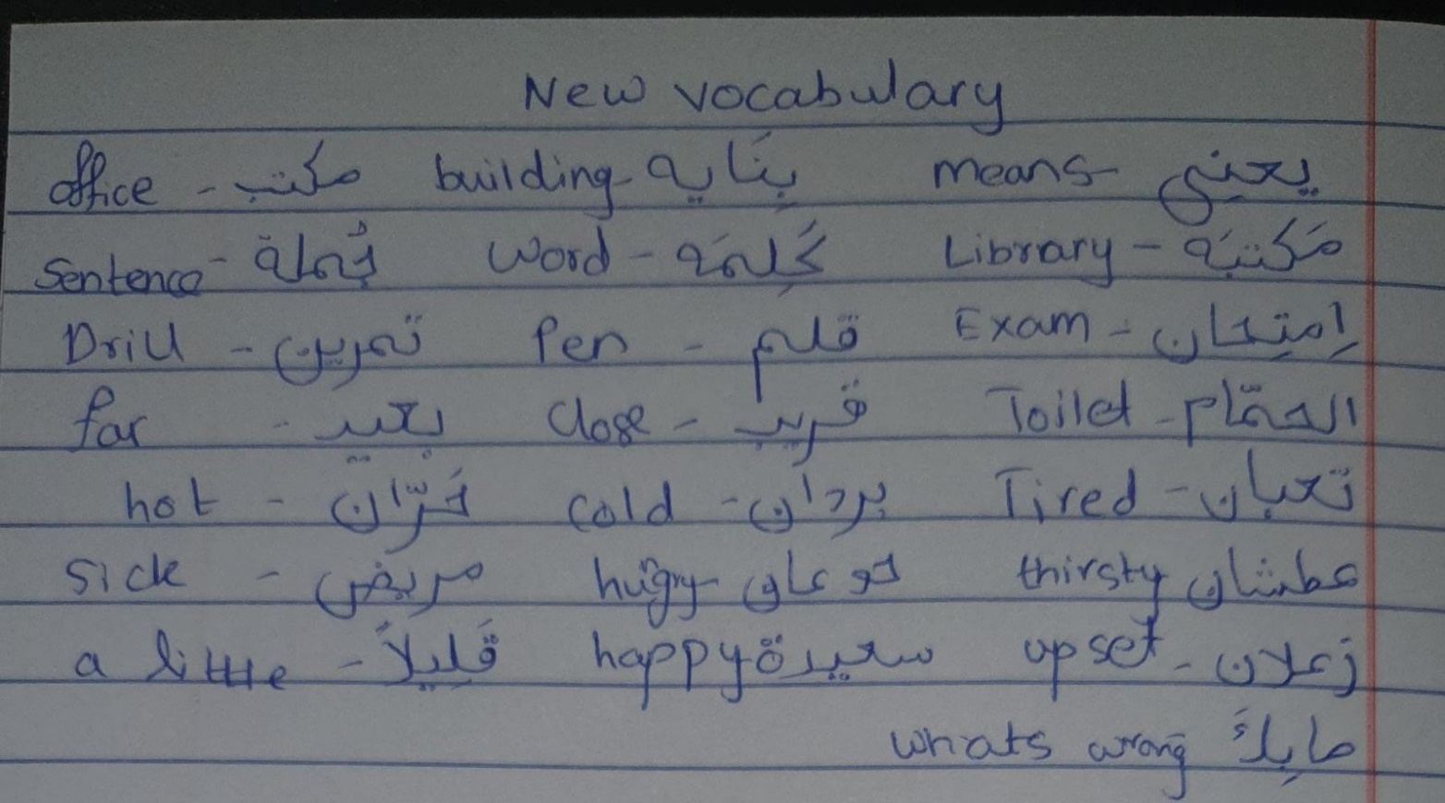

Drill 1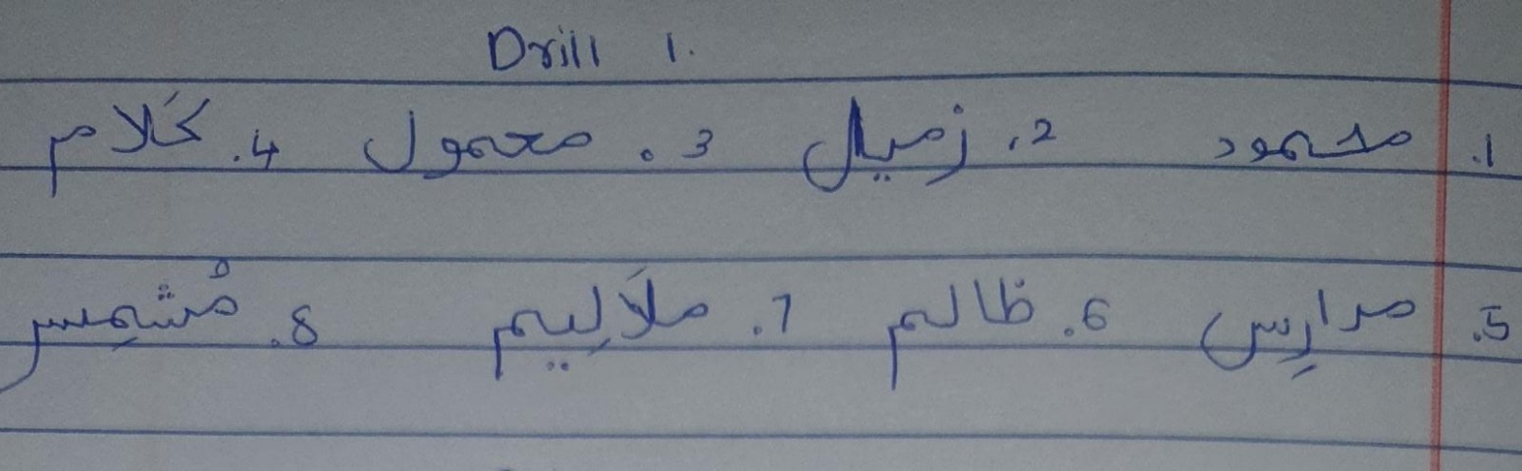

Drill 2

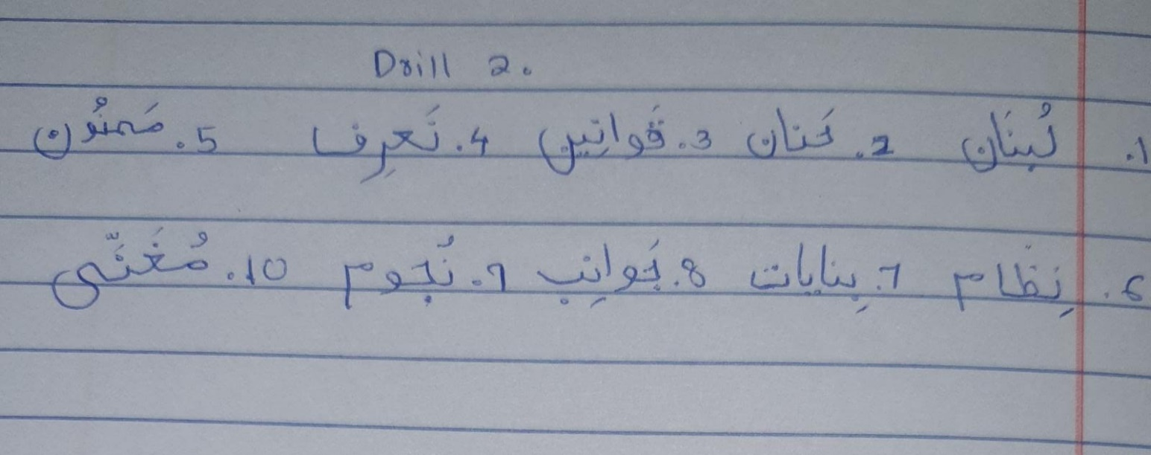

Drill 6

